**Smart Intruder Alert System**

Multi Disciplinary Design Project

(15CS303M)

**Members:**

Naman Gupta (RA1711003030118)

Deepanshu Sharma (RA1711003030101)

Jatin Choudhary (RA1711003030119)

Ashi Saxena (RA1711003030071)

**Submitted to:**

Mr. Mahesh Kumar Bhatt

ABSTRACT

Security has becoming an important issue everywhere. Home security Is becoming necessary nowadays as the possibilities of intrusion are increasing day by day. Safety from theft, leaking of raw gas and fire are the most important requirements of home security system for people. A traditional home security system gives the signals in terms of alarm. However, the GSM (Global System for Mobile communications) based security systems provides enhanced security as whenever a signal from sensor occurs, a text message is sent to a desired email to take necessary actions.

In this [IoT based Project](http://circuitdigest.com/internet-of-things-iot-projects), we will build a**Home Security System using PIR Sensor and PI Camera**. This system will detect the presence of Intruder and quickly alert the user by sending him a alert mail. This mail will also contain the Picture of the Intruder, captured by Pi camera. Raspberry Pi is used to control the whole system. This system can be installed at the main door of your home or office and you can monitor it from anywhere in the world using your Email over internet.

OBJECTIVE

* The main objective is to improve home security at low cost.
* Proper utilization of the GSM technology for home security.
* To prevent intruders from entering the home and provide access to only legitimate person.
* Enable the owner to monitor his/her home with live feedback through an application and provide home automation through application.
* We implement different IDS techniques i.e. Analogy based and signature analysis using different sensors and wireless camera for detection of intruder.

**Introduction**

**IoT (Internet of Things):**

The effect technology has on our lives is something beyond words. We are smarter, growing faster, learning in innovative ways and experiencing things every day, all because of technology and science. We might sit and contemplate on how forward and advanced the technology has become today, but those thoughts will hardly be able to match the levels to current advancement. So, while there is another new technology that is almost knocking on our doors, very few are aware of it.[Internet of Things](http://circuitdigest.com/internet-of-things-iot-projects)also known as ‘**loT**’ is the latest ongoing talk of innovation in the world.

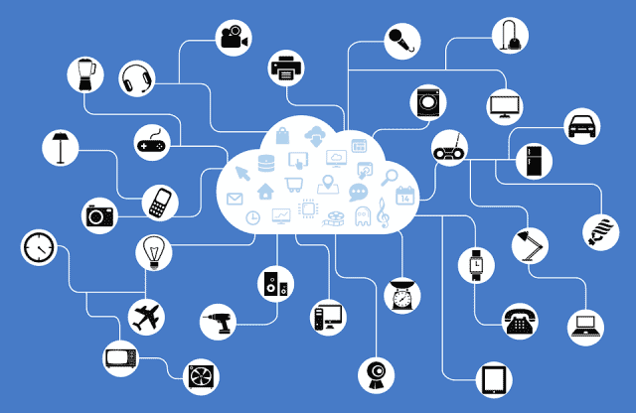

We all are aware of how internet has connected people to people, but now taking another step forward internet is going to connect things never thought before. Basically,**Internet of Things (loT)**is a system of devices and things that are implanted with sensors, software and electronics to initiate the exchange and collection of data and information**.**

**Internet of Things (loT)** first surfaced in the year 1999 when a Kevin Ashton a British entrepreneur while working in lab came up with the concept of it. 20 years forward to that incident, researchers quote that by 2020 the world will be using nearly 50 billion of devices that are governed by Internet of things. In all we all set to enter to an era where there will be a very advanced connectivity amongst network, systems and devices which will go beyond the application of human-to-machine and **machine-to-machine communications**. The development of **‘Smart Cities’**and **‘Smart Grid’** will witness the implementation of loT in several ways. Internet of Things has already begun changing the world.

**Applications of IoT:**

One key application of smart home is to provide [assistance for disabled and elderly individuals](https://en.wikipedia.org/wiki/Home_automation_for_the_elderly_and_disabled). These home systems utilize assistive technology to accommodate an owner's specific disabilities. Voice control can assist users with sight and mobility limitations while alert systems can be connected directly to Cochlear implants worn by hearing impaired users. They can also be equipped with additional safety features. These features can include sensors that monitor for medical emergencies such as falls or seizures. Smart home technology applied in this way can provide users with more freedom and a higher quality of life.

A second application of smart home is even more sophisticated. One can guide his or her connected device at home even from far away. If one for example leaves the office, it is possible to tell a connected air conditioner device via smart phone to cool down the house to a certain temperature.

Another example would be using smart devices such as [Amazon's Alexa](https://en.wikipedia.org/wiki/Amazon_Alexa) to listen to news while cutting vegetables for a meal. In general, Smart Home devices make life easier at home and give users the ability to do several things at the same time.

**Examples of IoT:**

### ****Smart thermostats:****

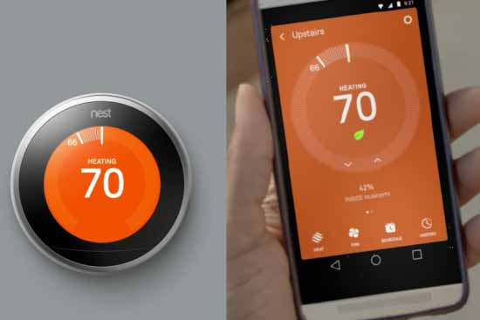

Imagine that you can control the temperature of your home from anywhere, with just a simple touch on your smart phone or tablet, and you get the desired temperature before getting home so that you don’t need to wait. [**Nest Learning Thermostat**](https://nest.com/thermostat/meet-nest-thermostat/) is the most popular Thermostat in this ‘Smart’ category; this company has been bought by **Google**. Nest thermostat not only controlled from anywhere but also it learns by itself by following your daily routing and change the temperature of your home without bothering you, Like if you have set low temperature at night continuously for 7 days, then this device learns that and automatically lowers the temperature at night. This is very helpful device for saving the energy.

### ****Philips-Hue Bulbs:****

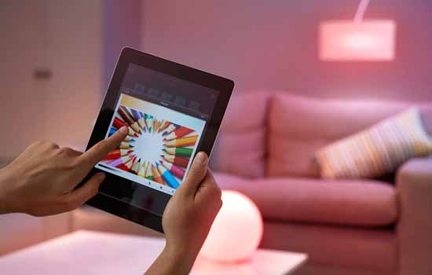

**Philips hue bulbs** have now stepped into a new stage of innovation with these smart bulbs. Linked with your mobile phones, you can now actually control the intensity of lights on your fingertips. The combination of bulb with mobile technology is next thing for your home. Instead of going for different watt of bulbs to suit the mood and the environment, simply change the intensity from dim to medium to full using your phone. These bulbs can be programmed to get dim at night, also it can work as a alarm by setting it in blinking mode on any intruder detection. The lighting can be dynamically change according to the environment, like a different lighting when watching a movie. ON and OFF timer can also be set for these bulbs to automatically ON and OFF after a particular time.

**Apple Watch and HomeKit:**



And the most talked company of gadgets and devices. Apple has changed the world with its inventive and ultra-modern devices. Be it phones, laptops or any other electronic device, Apple has itself strongly established. The **Apple watch** is the example of how advanced the technology is at Apple. Apart from time and date, the Apple watch enables you to keep a track record of your health and daily activities. Also the voice activation allows you to get notifications in instant. View maps, listen to music and take care of your calls just by a single watch. Surprised at what a watch can do? Well, it’s has lot more features for you to explore and make life easier.

Apart from Apple watch, Apple has also released **Apple HomeKit Framework**, which enables Siri (voice assistant in Apple’s iOS) to communicate with the devices and accessories at your home, so that they can be controlled remotely.

### ****Smart Refrigerator:****

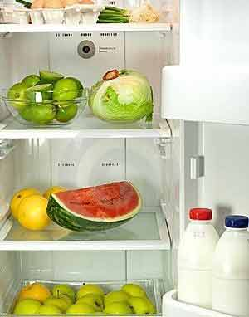

Have you ever experienced a situation when you have some friends at home and you opened the fridge for some cold drinks and there were no cold drinks in the refrigerator! In that situation you must have wished that, someone would have informed you about the cold drinks and you had bought them before. But don’t worry, now this is possible with IoT, **Smart refrigerators** are there, which not only inform you about the consumed items or empty bottles in the fridge but also order them online before they runs out. These refrigerators can do much more than this although the production has not started at big scale yet.

### ****Smart Phones:****

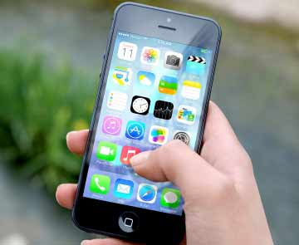

Everybody knows about the smart phones now, and **Smart Phones** are the most common example of IoT or we can say Smart Phone is one of the first few “Things” in the ‘Internet of Things’. All the devices explained above can be controlled using your smart phone and smart phone is become the center of this network like the stick of the magician. Like a magician do the magic by moving his stick, Smart Phone can do the “Real magic” by just few touches.

### ****Smart cars:****

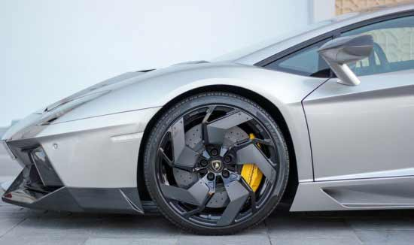

The automotive companies like Ford; Tesla has already stepped into the world where Car would also the part of IoT. **Tesla car** is really a big achievement in this field. Imagine that a car automatically opens the garage door before you arrive at home and you can remotely control the temperature, lights, charging of the car. Tesla car have these entire feature, it also have a App framework where you can build your own app to control the car and know its speed, location, battery status from anywhere. The car can upgrade itself automatically by downloading and installing the latest firmware and software. It has 18 sensors to automate the things, and it can fix a service schedule at the car service station by itself.

### ****Microchips:****

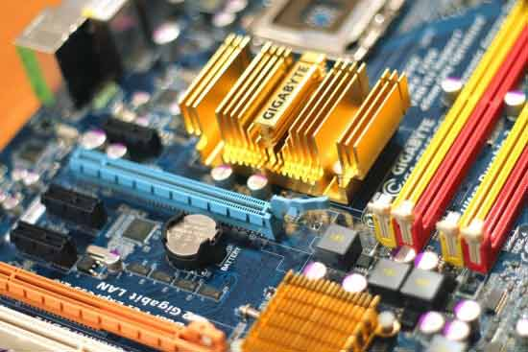

We are hearing about microchips for a long time and have their applications in some of the sensitive and dangerous fields like defense. But now one of the most integrated circuit have found its way to our day-to-day life. Microchips are generally used in the forms of tracer as the radar detectors can detect data about various things. Now with ioT, you can fit a microchip on collars of pet or attach it to them to keep a track of their movement without being physically looking for them. There is more freedom to your pets now and this also enables you to keep a record of their health too.

### ****Google Glass:****

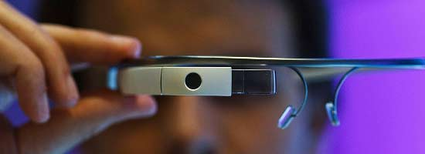

We are talking about innovation and how can we forget to mention the company that defines innovation and internet the best. Google has always come up with things that have made our life easy always and with **Google glass** it is more like repeating history for the company. A headset designed with optical-head display, if only you knew eyeglasses could be this much efficient. You can now wear it and together with voice activation you can interact, see, surf the net, click pictures and do many others things in a Smartphone-like-hands-free form. This Google glass is the result of ‘Project Glass’ from Google.

The development of **‘Smart Cities’**and **‘Smart Grid’** will witness the implementation of loT in several ways. Internet of Things has already begun changing the world and we have entered a new technological era

**About the project:**

The internet of Things has many other innovative devices to introduce to the world which will simply leave you amazed and thrilled. We are talking about technology that a decade from now will be marvelous amazement of science playing a yet another important role in our lives.

Home security has changed a lot from the last century and will be changing in coming years .Security is an important aspect or feature in the smart home applications. The new and emerging concept of smart homes offers a comfortable, convenient, and safe environment for occupants. Conventional security systems keep homeowners, and their property, safe from intruders by giving the indication in terms of alarm. However, a smart home security system offers many more benefits.

In the world of [Internet of Things (IoT)](http://circuitdigest.com/ten-examples-of-internet-of-things-iot) when we have all the technologies to revolutionize our life, it's a great idea to develop a system which can be controlled and monitored from anywhere.  There are many types of good security systems and cameras out there for home security but they are much expensive so today we will build a low cost simple **Raspberry Pi based Intruder Alert System**, which not only alert you through an email but also sends the picture of Intruder when it detects any.

In this [IoT based Project](http://circuitdigest.com/internet-of-things-iot-projects), we will build a**Home Security System using PIR Sensor and PI Camera**. This system will detect the presence of Intruder and quickly alert the user by sending him a alert mail. This mail will also contain the Picture of the Intruder, captured by Pi camera. Raspberry Pi is used to control the whole system. This system can be installed at the main door of your home or office and you can monitor it from anywhere in the world using your Email over internet.

Whenever anyone or intruder comes in range of PIR sensor, **PIR Sensor triggers the Pi Camera through Raspberry Pi**. Raspberry pi sends commands to Pi camera to click the picture and save it. After it, Raspberry Pi creates a mail and sends it to the defined mail address with recently clicked images. The mail contains a message and picture of intruder as attachment.

This project mainly focuses on the security of a home when the user is away from the place. Two systems are proposed, one is based on raspberry pi technology and other uses web camera to detect the intruder. The first security system uses a web camera, installed in house premises, which is operated by software installed on the PC and it uses Internet for communication. The camera detects motion of any intruder in front of the camera dimensions or camera range. The software communicates to the intended user via Internet network and at the same time it gives sound alert.

The second security system is e mail based and uses raspberry pi technology to send the email to the owner. The proposed system is aimed at the security of Home against Intruders.

In any of the above cases happens while the owners are out of their home then the device sends email to the emergency email address which is provided to the system.

**Software and hardware required**

**Hardware:**

* Raspberry Pi
* Pi Camera
* PIR Sensor
* LED
* Bread Board
* SD Card
* Piezo Speaker
* 100ohm Resistor
* Connecting wires
* Power Supply

**Software:**

* Raspbian (Linux based OS for Raspberry Pi)
* Python

**Main components of the software:**

**Raspberry Pi:**

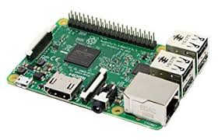

A **Raspberry Pi** is a credit card-sized computer originally designed for education, inspired by the 1981 BBC Micro. Creator Eben Upton's goal was to create a low-cost device that would improve programming skills and hardware understanding at the pre-university level.

A lot of computer companies were named after fruit. There's Tangerine Computer Systems, Apricot Computers, and the old British company Acorn, which is a family of fruit. **Pi** is because originally we were going to produce a computer that could only really run Python. So the **Pi** in there is for Python.

The **Raspberry Pi** is a series of small single-board computers developed in the United Kingdom by the **Raspberry Pi** Foundation to promote the teaching of basic computer science in schools and in developing countries.

Raspberry Pi is a low-cost, basic computer that was originally intended to help spur interest in computing among school-aged children. The Raspberry Pi is contained on a single circuit board and features ports for:

* HDMI
* USB 2.0
* Composite video
* Analog audio
* Power
* Internet
* SD Card

The computer runs entirely on open-source software and gives students the ability to mix and match software according to the work they wish to do.

**Pi camera:**

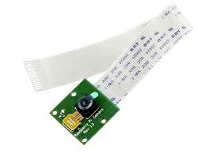

The **Camera** Module can be used to take high-definition video, as well as stills photographs. ... It supports 1080p30, 720p60 and VGA90 video modes, as well as still capture. It attaches via a 15cm ribbon cable to the CSI port on the Raspberry **Pi**. The **camera** works with all models of Raspberry **Pi** 1, 2, and 3.

In terms of still images, the **camera** is capable of 2592 x 1944 pixel static images, and also supports 1080p30, 720p60 and 640x480p60/90 video. The **camera** is supported in the latest version of Raspbian, Raspberry **Pi's** preferred operating system.

The most important of these, for understanding the **Pi's camera**, is that many mobile **cameras**(including the **Pi's camera** module) use a rolling shutter to capture images. When the **camera** needs to capture an image, it reads out pixels from the sensor a row at a time rather than capturing all pixel values at once.

**PIR sensor:**

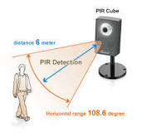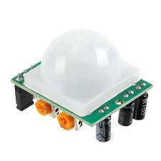

A passive infrared **sensor** (**PIR sensor**) is an electronic **sensor** that measures infrared (IR) light radiating from objects in its field of view. They are most often used in **PIR**-based motion detectors.

When the **sensor** is idle, both slots detect the same amount of IR, the ambient amount radiated from the room or walls or outdoors. When a warm body like a human or animal passes by, it first intercepts one half of the **PIR sensor**, which causes a positive differential change between the two halves.

**PIR sensors** allow you to sense **motion**, almost always used to detect whether a human has moved in or out of the **sensors** range. They are small, inexpensive, low-power, easy to use and don't wear out. ... They are often referred to as **PIR**, "Passive Infrared", "Pyroelectric", or "IR **motion**" **sensors**.

Infrared sensors have been widely utilized for remote based applications such as in televisions etc. This article will detail with a Passive Infrared Sensor. Read to know more about **PIR sensor**, their types, history, working etc.

**DFD**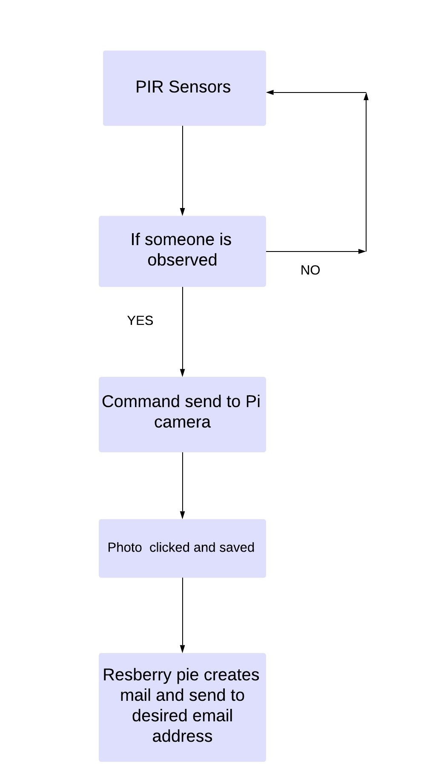

**UML CLASS DIAGRAM**

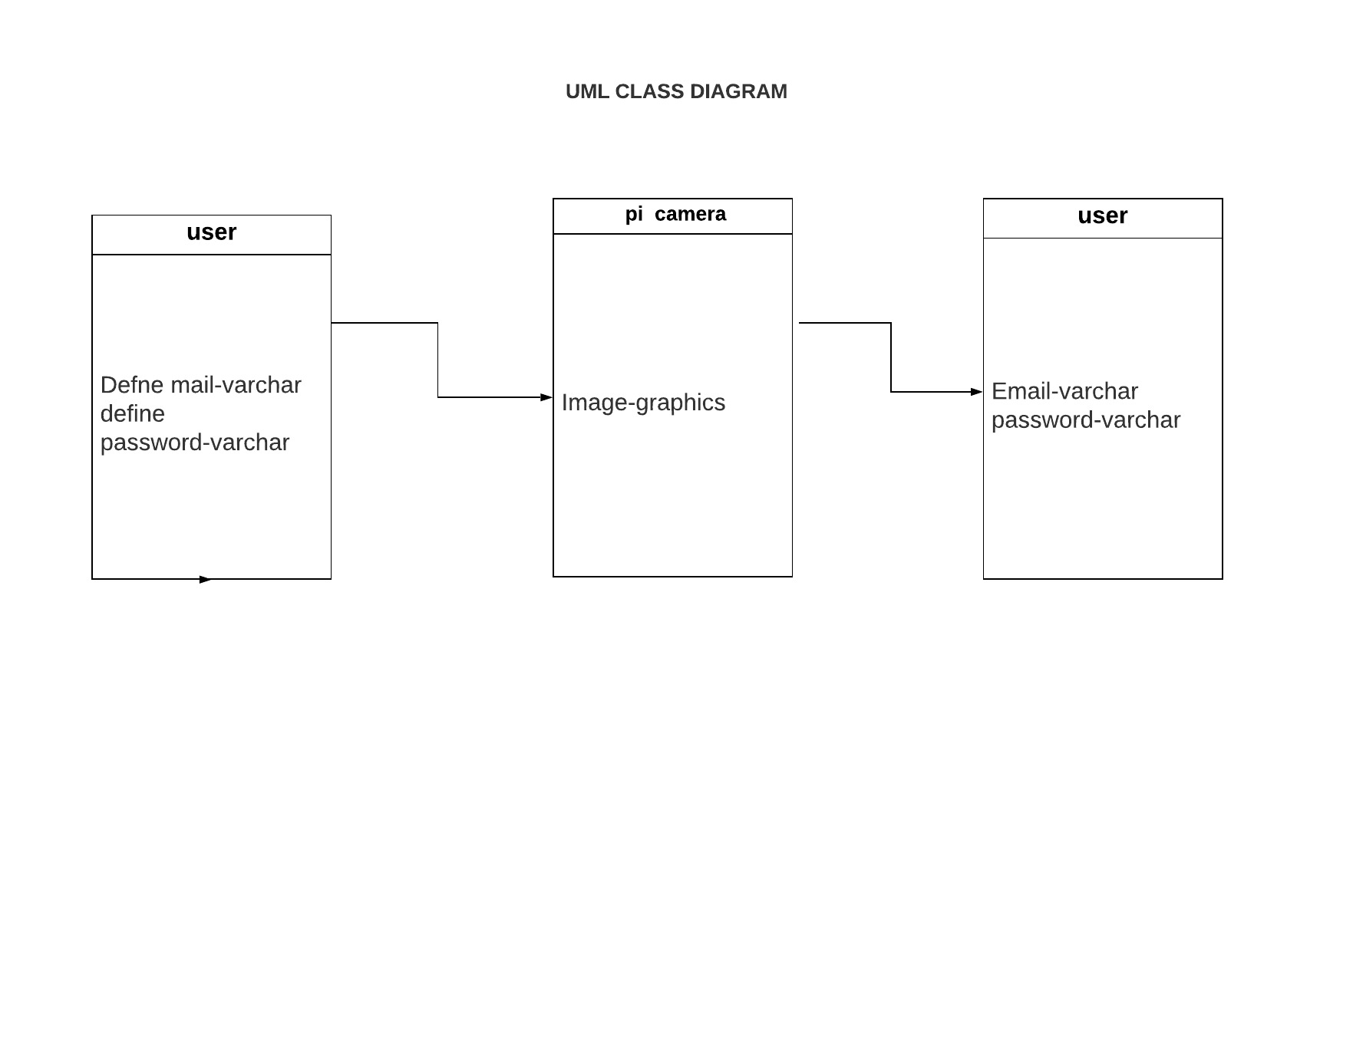

**UML SEQUENCE DIAGRAM**

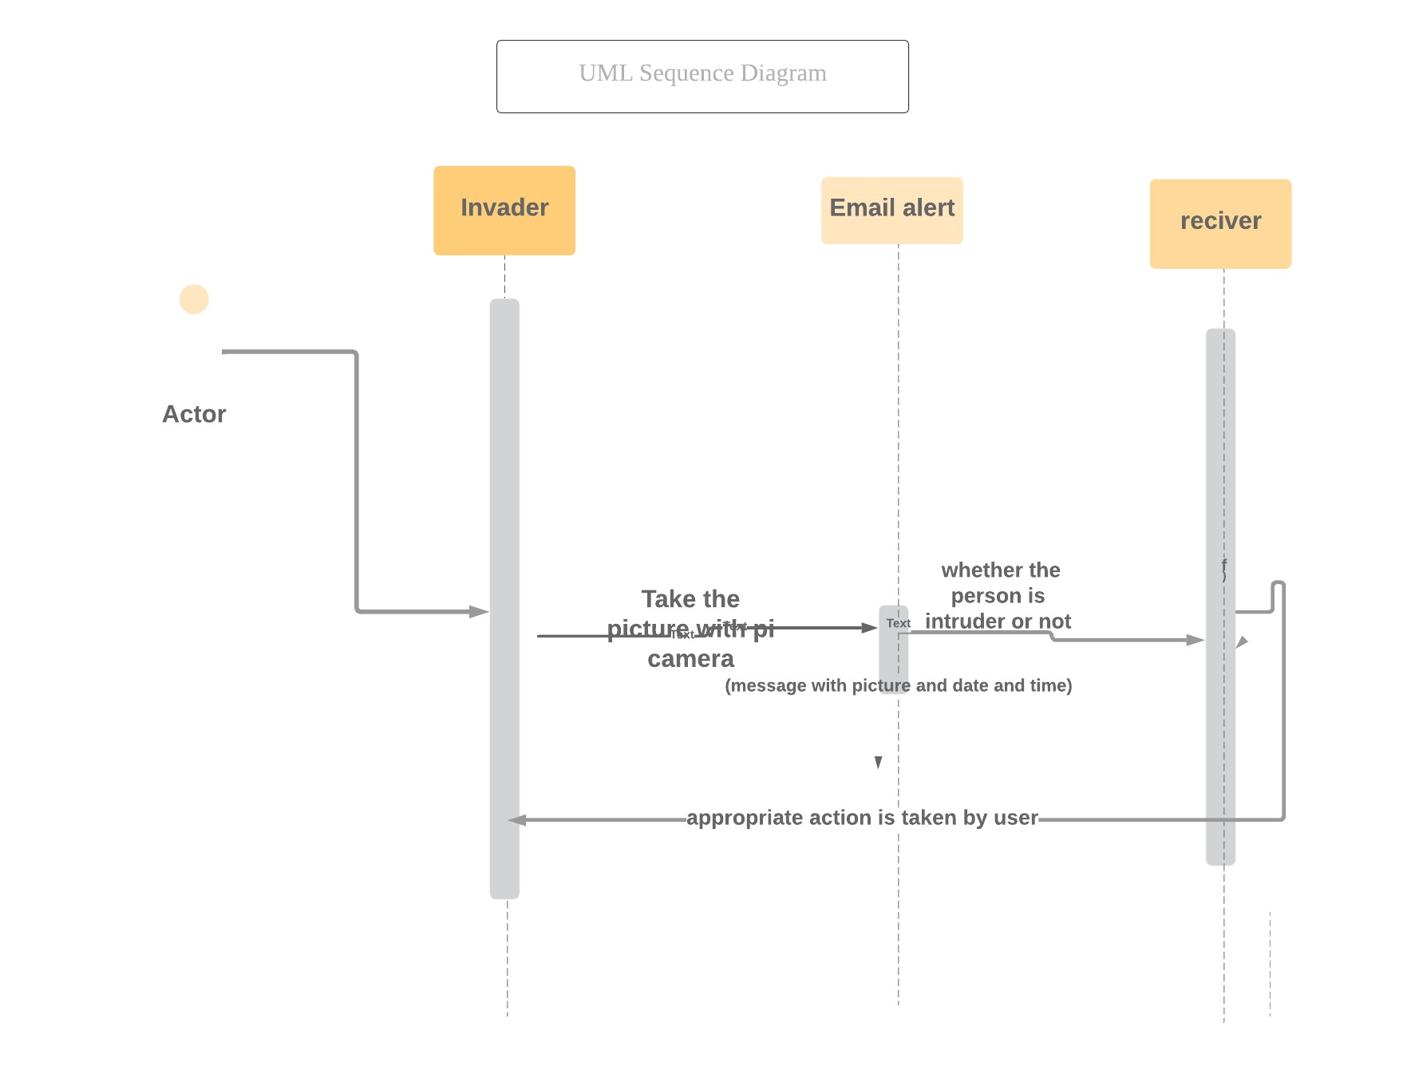

**FLOW CHART**

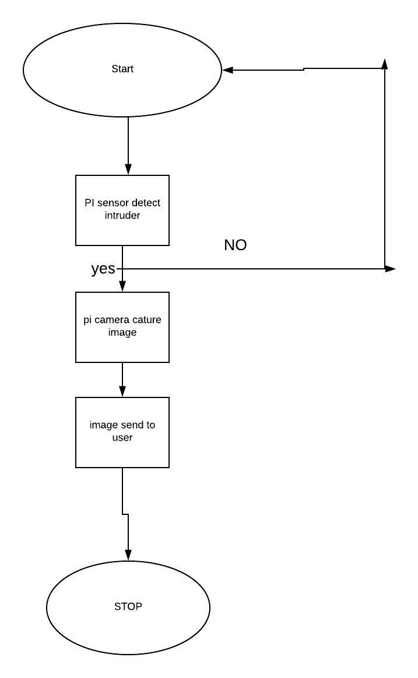

**Product Scope**

Product scope in India:

* Big companies like Philips, Siemens & Schneider will eventually bring out fairly mass market security products with appealing user interface but at a lower price point than today, and more people will be able to afford the products
* Solution offerings will slowly move to a more user friendly design, where aside from a few key components, users will be able to buy and use the Security products themselves without the aid of any technical expert.
* Some foreign players will have niche in high end security and focus on the premium market (>20 Lakh ticket size).

Co modification of Security market (2021 onward):

* As with any industry, as Security for residences become common, the market will eventually be crowded with multiple product offerings and competitive pricing. The market for just Home security is estimated to be $3.2 Billion by 2020.
* The products themselves will reach a ‘**plug and play’**type of usability, where users can simply purchase pieces from the store and use it themselves without any support from professionals.
* Many (most) houses will incorporate some aspect of Security in the home, from Lighting to security to HVAC elements. Home Security will be as common as having a Fridge or Television in the house.

**Problem identification**

**Reliability:** If your product cannot fall back to some lower standard of useful functionality when an internet connection is unavailable, the consumer's valuation of your product will be harmed every time their internet connection has problems. This creates a large third-party dependency for smart device companies.

**Security**: Implementing strong security measures is essential for IoT vendors if their products are not to become a vector for spying, blackmail, DDoS attacks or worse. Developers need to consider solutions that force default passwords to be changed, and implement end-to-end encryption between devices.

**Data collection and use**: In addition, failing clearly to inform consumers about how their data is collected, stored and processed may breach the GDPR and result in fines of up to €20m or four per cent of global annual turnover, whichever is higher.

**Digital transformation and integration**: These professionals still represent key intermediaries for consumer choices about major installation projects. Vendors that understand this, and provide software tools which can be deployed to interact with particular products, are more likely to benefit from the goodwill generated in professional community.

**Liability**  
Solutions to smart device problems often come in the form of updates and patches, which aren't always completely reliable. Developers also need to bear in mind that not all users will download updates as they become available, leading to 'version lag' as devices continue to run older software. Where the relevant manufacturer has partnered with another device manufacturer or platform provider, these kinds of liability issues can be addressed in the agreements that govern the commercial relationship.